**9 Reasons to Stop Poisoning Your Pup with Unnatural Dog Treats**

Knowing what’s in your pup’s dog treats can be tricky.

You want to believe what you see and hear, but when you can’t even pronounce more than half of the ingredients on the label, lots of questions come into play.

You try a brand that proclaims its “naturalness,” then you’re disappointed when your dog gets sluggish, or ill…*or worse!*

Then, there’s the price you paid. You were sure that was some sort of “guarantee” that you chose the best-out-there treats. Yet still, you come up empty handed. You feel cheated, taken advantage of, and made a fool.

*That’s never a good feeling.*

We just want what’s best for our furry family members.

*Why should that be so hard to do?*

**Here Are 9 Reasons to STOP Poisoning Your Dog with Unnatural Dog Treats**

1. Improved Immunity – By choosing natural dog treats with healthy ingredients like brown rice, potatoes, green beans, and other vegetables you not only prevent illnesses, but you also enhance their health. A write-up on thefarmersdog.com explains how an ingredient like carrots and their beta carotene converts to Vitamin A, which supports eye health, cell growth and immune function.
2. Better Dental Health – According to NBCNews.com, veterinarians recommend natural dog treats because they aid in oral health and plaque removal of your pup’s teeth.
3. Boredom Busters and Chewing Prevention – Dogs like to chew on things, and they like to be active. Along with the benefits of exercise, you want to keep your canine free of boredom (and distracted from those new shoes or antique furniture you just purchased).
4. Weight Management – AskVet.app lists ingredients that natural dog treats include in their treats and informs us that caloric intake is a factor in maintaining a healthy weight for our pets. Without additives and chemicals in dog treats, you can be sure you will keep your pup in top form.
5. Better Ingredients – Natural dog treats also don’t contain any of those mystery ingredients you hear about all the time like chemicals, hormones, and additives. Elements like fiberous carrots, wholesome brown rice, hearty sweet potatoes, lean poultry, protein-rich liver and beef, and farm fresh eggs, as well as green beans and pumpkin assist in the continual health of your pup.

And ***NO CORN*!** Corn is known for causing canine allergies! According to wagwalking.com, corn is an allergen for dogs that causes itching, hives, constant licking, vomiting and diarreah just to name a few of the symptoms!

1. More Calm, Less Stress – In an article from AnimalWellnessMagazine.com, ingredients such as sweet potatoes and brown rice offer calming effects from the tryptophane they offer.

In fact, the Mayo Clinic has conducted studies on the replacement of anti-anxiety medication with complex carbs due to the calming effects they provide!

1. Easier Digestion – We hate watching our pups get ill or feel under the weather. There are allergic reactions, ingredient intolerances, hormones, and additives to consider that don’t always agree with our furry friends’ stomachs.

Natural dog treats help avoid that happening because the ingredients are all natural, straight from the source, and produced farm-to-package in some cases.

1. Better Value – When taking our wallets into consideration, some companies take on a value-driven and health-driven mission. Why pay for dog treats that claim they are “all natural” when you can pay about the same amount for truly natural treats for your pup? It just makes sense.
2. Your Peace of Mind – As a pet parent, our peace of mind about our pup’s health is just as important as the previous items listed above. When we can feel confident that we are giving our canines a healthy treat made from truly natural ingredients, we can feel at ease about it too.

You can see why having knowledge about the ingredients in your pup’s natural dog treats is so important. You want to keep them around as long as you can and keep them happy, healthy, and active. Considering the source of healthy dog treats is a first step in doing that. Just because these natural dog treats say ‘natural,’ doesn’t necessarily mean they are.

For more on true natural dog treats, click here.

**All-Natural Dog Treats | No Hormones, or Chemicals | Free Training Guide**

[www.puptasticnaturals.com](http://www.puptasticnaturals.com)

Learn to train your pup with natural treats and impress your friends with our easy guide!

Click here to get started today before this free offer ends!

**FREE NATURAL DOG TREAT TRAINING GUIDE …BE THE HERO OF YOUR NEIGHBORHOOD**

Thanks for clicking over for your FREE GUIDE “**Training Your Pup with Natural Dog Treats**”.

Now you can be the hero everyone in your community wants to be, training your dog to do magnificent tricks that even he will enjoy and look forward to.

**See just how easy and fun it can be …**

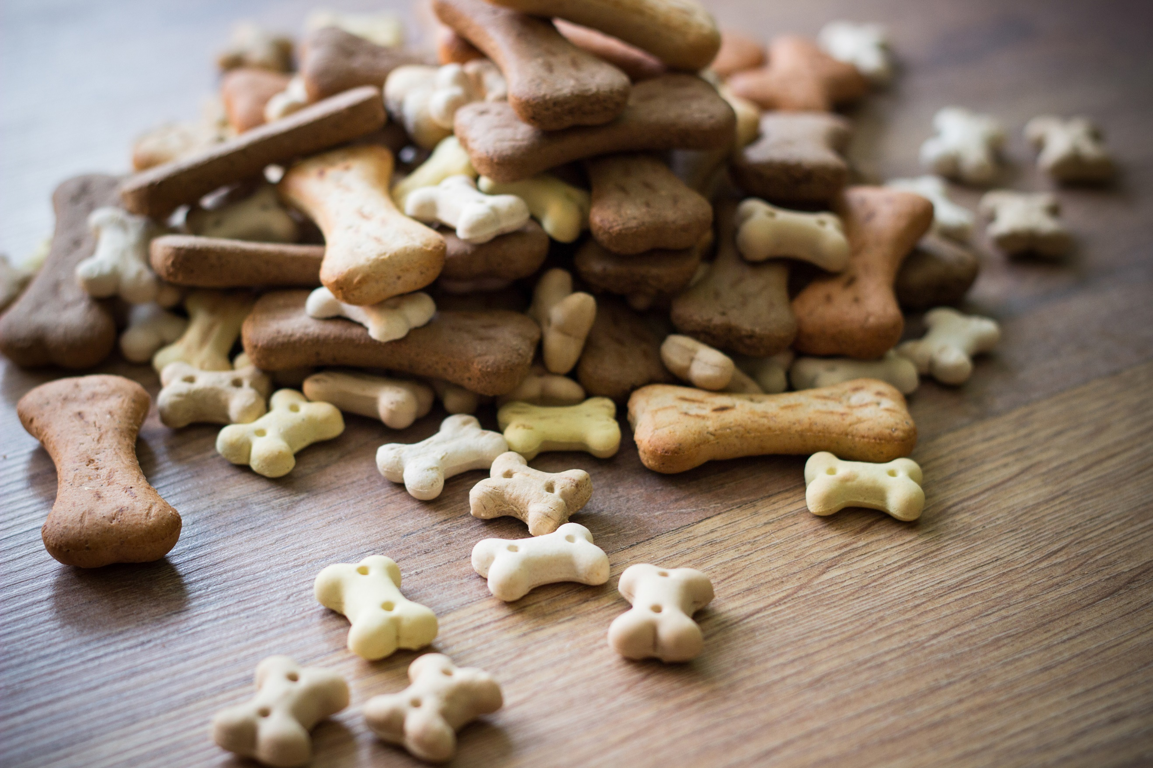

* Discover how to earn respect from your neighbors when they see just how disciplined your pup truly is.
* Fun tricks that are easy to train your dog to do that your friends and family will be jealous of and want to learn to do themselves.
* Have fun with your canine friend while instilling commands and respect at the same time.

**CLICK HERE TO ORDER YOUR ABSOLUTELY FREE DOG TRAINING GUIDE!**

**Hurry, this one-time-only free offer lasts!**

**ORDER NOW to get the FREE TRAINING GUIDE and the admiration of your friends and family. Your pup will thank you too!**

**Keep Your Dog Healthy and Living a Long Life**

Michael,

Thanks for downloading our FREE NATURAL DOG TREAT TRAINING GUIDE. By now, we’re sure you’re showing off to those you know all you learned from it and having fun with your pup at the same time!

On a separate note, did you know that most dog owners hesitate when asked what’s in their dog treats?

In fact, a lot of them think that if the packaging says ‘natural’, they believe the treats are safe and healthy for their furry friend.

As shocking as that sounds, there are other reasons to educate yourself and know what ingredients are truly in those ‘natural’ treats:

* You could possibly be putting toxins and harmful chemicals into your dog’s body by giving him those so-called ‘natural’ treats.
* Several dog treats advertised as ‘safe for animals’ were manufactured outside of the country where food safety regulations are not as strict as they are in North America.
* Added fat, calories, sugar, and other unhealthy factors may secretly be hiding under the “unlisted” mystery ingredients of that ‘natural’ dog treat ingredient list.

So, how do you find the right dog treat for your pup?

A specific dog treat company has found a truly natural method of sourcing and making natural dog treats that take the questions and hesitations out of deciding which treats are best for your dog.

They’ve discovered a practical, resourceful, and farm-to-package method of curating ingredients to make their natural dog treats that take the guessing and confusion out of the entire process.

Click HERE for the details.

**To Your Pup’s Good Health,**

*Jenn*

P.S. Don’t let this opportunity to learn more get away! Your pup depends on you to know what’s in his treats. Click here to learn more about why this is so important!

**You Need to Know Right Now If Your Pup’s “Natural” Dog Treats Are Killing Him**

Dear Fellow Dog Lover,

You love how your canine snuggles up to you. How he sits attentively at your feet. You adore the sense of companionship and protection he gives you. Even when humans let you down, your pup is always there. Unconditionally. *No matter what.*

Could it be that look he gives you? You know the one - those piercing eyes that see through your soul almost. And how about those heavy sighs that correlate with your mood when you’ve had a tough day, as if to say, “*Hi there. I feel you,” as* if he knows exactly what you’re going through.

You love your dog. And you know he loves you. He’s been through everything with you over the years. Breakups. Scary movies. Celebrations. He’s been by your side since he’s been in your life. He knows when he’s loved. Why not ensure his life is the absolute best you can offer him by giving him Puptastic Naturals Dog Treats?

**Why “Natural” Dog Treats Aren’t Always Safe**

Don’t you want to know what’s *truly* in those “natural” dog treats? You want to know what’s in your own food, right? What’s beneficial and what’s not so great? What will energize and sustain you? Support your health and keep you living your best life? Your pup is your buddy in life. Don’t forget *you’re in this together*.

***“I love how much my sweet Betty loves Puptastic Naturals!***

***When I first gave her a Puptastic Naturals Dog Treat, she***

***gobbled it up in no time. The small bite-sized shape makes***

***it easy for her to chew and swallow compared to previous***

***treats I have bought for her.” –* Sarah Smith – Spokane, WA**

**Sarah Smith – Spokane, WA**

Knowing what his dog treats are made of is important. It’s what will keep him there by your side for many years to come. Through your tears, cheers, and in-betweens. The longer you care for what’s going into *his* system, the longer you’ll *have* him as your best friend in this life.

There’s a lot of information out there about natural dog treats. And a lot of that information *is pretty scary*. There are celebrity-endorsed treats, packaging in vibrant colors, and cleverly crafted names *and flavors* to give us a laugh, entice our own appetite, or warm our hearts just by saying the name aloud.

*But what really matters here*? Let’s consider some not-so easy to handle facts about those “natural” canine treats …

**The Solution to Your Dog Treat Concerns**

Puptastic Naturals, small batch, unprocessed organic dog treats available from May and Tom Stratton, dog owners that have been making these treats from their Midwest kitchen in the Chicago-based village of Grayslake, Illinois since 1990. This couple’s success in sourcing ingredients from local farms focusing on organic, healthy practices for raising poultry, cattle and growing produce is unsurpassed. That’s why they give Puptastic Naturals to their own pack of beloved dogs!

**Scary Experiences You Can Avoid by Using Puptastic Naturals Dog Treats**

* **Your pup getting sick from “mystery” ingredients** – Puptastic Naturals has nothing to hide and wants to provide only the best natural products. You know dogs will eat ANYTHING, so why not give them something you know is good for them without upsetting their stomachs?
* **Choking on treats that are too large** – Puptastic Naturals offers bite-sized treats that your pup will have an easy time chewing and swallowing. They’re also convenient for traveling and training!
* **Treats that *don’t* list all the ingredients** – No worries about what’s been left off the ingredients list. Puptastic Naturals include clear, understandable whole ingredients like pumpkin, sweet potato, eggs, lean poultry, brown rice, and beef – NO CORN, which can create intestinal blockages and cause choking hazards!
* **Unsavory flavors** – Puptastic offers craveable flavors that have been dog tested like chicken, turkey, lamb, liver and beef. (Or mix the flavors together for an unexpected treat!)
* **Pet parents prefer Puptastic Naturals to the standard mass-produced “natural” dog treats** – compared to most popular commercially-advertised treats, Puptastic Naturals provides honest, science-backed, small batch treats with no “mystery” ingredients. In fact, in an article from [**www.greatpetcare.com**](http://www.greatpetcare.com), they share that Vitamin E is one of the ingredients which assists in keeping the immune system in good health with antioxidant qualities, which Puptastic includes in their recipe.

For new customers, Puptastic Naturals is offering an exclusive offer just for you. Request a Trial Sampler coupon at **www.puptasticnaturals.com** and you’ll not only get a generous sample of these 100% natural organic dog treats (**a *$20.00 VALUE!)***, but they will kick in a first-time buyer discount of 30% off your first order! (*Now* ***that’s*** *belief in your product!)* Just contact the customer service reps from 9 AM to 6 PM EST Monday through Friday.

Trust Puptastic Naturals treats for your cherished dog. Mary and Tom make these treats from their very own kitchen using hand-selected ingredients that follow chemical-free, organic, natural practices. Baked in a “people food-quality” oven in a kitchen exceeding standard of the FDA (Food and Drug Administration) and the AAFCO (Association of American Feed Control Officials) their treats are some of the best natural dog treats you can get your own *paws* on. Do what’s right for your peace of mind and for your pup’s health. Give them Puptastic Naturals – *BECAUSE YOU LOVE THEM.*

Looking out for you and your pup,

Jenn

P.S. Just to sweeten the deal, the folks at Puptastic Naturals are so sure you and your pup will enjoy the benefits of their treats that they are offering a ***100% MONEY BACK GUARANTEE EVEN IF YOUR DOG EATS THEM ALL!*** That’s right-on EVERY order! The makers of these treats are so sure your pup will benefit from and enjoy these that they are willing to give you a **full refund** for your purchase even if they are gobbled up by your pup!